

| Smartphone MuseUM App | |
| --- | --- |
| Project Charter Plan | |
| Academic year | 2024/2025 |
| Lecturer | João Varajão |
| Degree | Master's in Telecommunications and Computer Engineering (METI) |
| Year | 2nd Year |
| Curricular Unit | Gestão de Projetos de Tecnologias de Informação (GPTI) |

## 

## 

## 

## 

# The Team 03

The team is made up of four members, three of whom are 2nd year students on the Master's in Telecommunications and Computer Engineering and are identified by PG (Postgraduate) followed by their mechanography numbers, while the fourth member is an Erasmus student on the same degree and is identified by the code E (Erasmus) followed by his mechanography number.

###### Catarina da Cunha Malheiro da Silva Pereira

PG53733

[pg53733@alunos.uminho.pt](mailto:pg53733@alunos.uminho.pt)

Braga, Portugal

###### Inês Cabral Neves

PG53864

[pg53864@alunos.uminho.pt](mailto:pg53864@alunos.uminho.pt)

Porto, Portugal

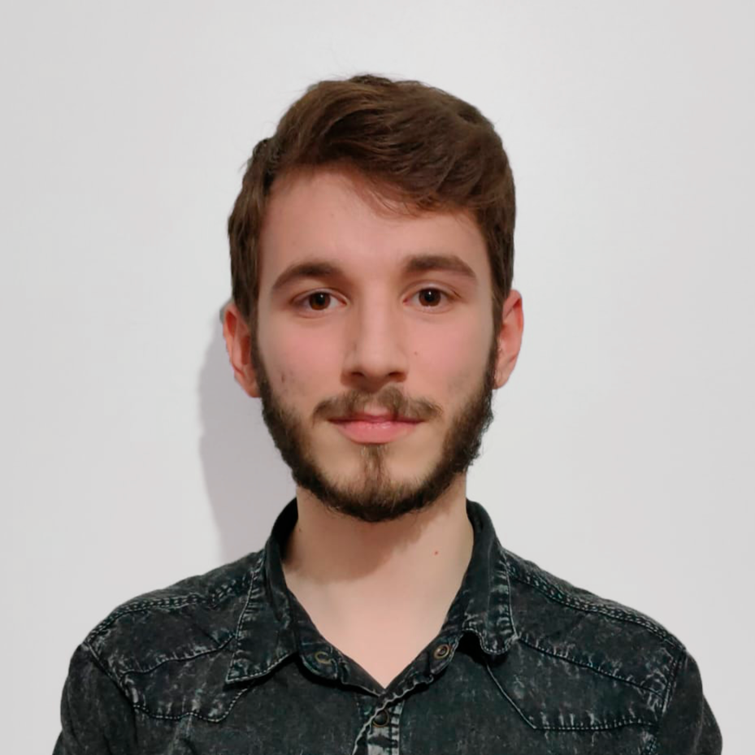

###### Leonardo Dias Martins

PG53996

[pg53996@alunos.uminho.pt](mailto:pg53996@alunos.uminho.pt)

Aveiro, Portugal

###### Rodrigo Rocha del Castillo

E12165

[e12165@alunos.uminho.pt](mailto:e12165@alunos.uminho.pt)

Santander, Spain



| table of contents | **The Team 03 __________________________ 01** |
| --- | --- |
| **Table of Contents _____________________ 02** |
| **List of Figures_________________________04** |
| **List of Tables__________________________05** |
| 1. **Executive Summary _____________________06** |
| 1. **Framework ____________________________07** |
| 1. **Justification ___________________________08** |
| 1. **Purpose/objectives _____________________09** |
| 1. **Deliverables __________________________ 10** |
| 1. **Requirements _________________________ 11** |
| 1. **Stakeholders _________________________ 12**    1. **Stakeholders Identification _______ 12**    2. **Stakeholders Matrix ____________ 13** |
| 1. **Sponsor & Team Structure ______________ 14**    1. **Sponsor ______________________ 14**    2. **Team Structure ________________ 14** |
| 1. **Timeline & Milestones ___________________ 15** |
| 1. **Resources & Budget ____________________ 16** |
| 1. **Restrictions __________________________ 17** |
| 1. **Assumptions __________________________ 18** |
| 1. **Other Factors ________________________ 19**    1. **Success Criteria ________________ 19**    2. **Success Factors ________________ 19** |
|  | 1. **List of Risks ___________________________21** |
|  | **Declaration of Knowledge __________________ 22** |



| **Figure 1: Stakeholder Matrix _______________ 13** | table of Figures |
| --- | --- |
| **Figure 2: Milestones _______________________ 15** |
|  |
|  |
|  |
|  |
|  |
|  |
|  |
|  |
|  |
|  |
|  |
|  |



| table of Tables | **Table 1: Roles and Responsibilities _______________ 14** |
| --- | --- |
| **Table 2: Budget Perspective _____________________ 16** |
| **Table 3: Risks List_____________________________ 21** |
|  |
|  |
|  |
|  |
|  |
|  |
|  |
|  |
|  |
|  |
|  |
|  |
|  |



# Executive Summary

This document presents the Project Charter for the SmartPhone MuseUM APP Project, requested by Professor João Varajão.

The project aims to improve the experience of visiting the Smartphone MuseUM, which is currently accompanied by museum staff and DSI department.

Therefore, the main objective of this project is to develop a mobile application that provides a more interactive and autonomous visiting experience, allowing visitors to explore the exhibitions independently and, in the end, provide their feedback directly through the application.

In this way, this Project Charter serves as a guideline for the work team and the client, in order to ensure the necessary focus to achieve the objectives, which involve developing a mobile application.

This work will begin on 19th September 2024 and end on 10th December 2024, with a total duration of approximately 3 months and an overall budget of 6007.75 euros (€).



# Framework

The creation of the cell phone and computer has revolutionized the way people connect, making it possible to establish connections that were not possible before. Initially designed to facilitate communication between people, the cell phone has evolved rapidly with the advance of technology, becoming a multifunctional device. Today, it is a portable version of a computer, with capabilities that go far beyond communication.

However, this rapid technological evolution has brought with it an inevitable consequence: the accelerated obsolescence of equipment. Many older cell phones and computers no longer have the necessary software and hardware to meet today's demands, which emphasizes the importance of preserving and documenting the history of these devices.

The Smartphone MuseUM's mission is to preserve and disseminate the history of smartphones and related devices, with a special focus on their adoption, use and evolution over time. Through this mission, the museum contributes to society by preserving technological history, promoting educational activities for different audiences and encouraging research.

# Justification

Currently, visits to the museum are carried out exclusively with the accompaniment of a member of staff, which, although efficient, can limit interaction and personalisation of the visitor experience. This project aims to significantly improve the way visits are conducted by introducing a mobile application that will allow visitors to explore the museum in a more autonomous and interactive way.

Through the app, visitors will have access to detailed and complementary information about the exhibitions, tailored to their interests and pace of visit, providing a more enriching and personalized experience. In addition, the app will allow visitors to provide direct feedback on their visit, which will represent a valuable source of data for the museum. This feedback will help to identify what visitors like best, enabling continuous adjustments and improvements to be made to the exhibitions and the overall experience.

With this solution, the museum will not only be able to increase visitor satisfaction, but also optimize its resources by reducing its dependence on staff to guide visits. The implementation of this application is in line with the growing trend towards digitalisation and interactivity in cultural spaces, reinforcing the museum's commitment to modernizing and adapting to the expectations of an increasingly demanding and technological public.

# Purpose/Objectives

The aim of this project is to enrich the visitor experience by offering a more interactive and personalized visit. To achieve this goal, it is essential to obtain feedback from visitors, which will allow the museum to better adapt to their preferences and needs. To this end, a mobile application will be developed to facilitate this interaction and data collection.

The objectives of this project are:

* Obtain feedback from customers;
* Identify the application's requirements;
* Develop the application for the museum;
* Programming, documenting and testing the application.

# Deliverables

The primary goal of the deliverables is to ensure that all materials requested by the client are clearly identified and provided by the conclusion of the project. The following items will be delivered:

* **Application mockup:** A visual representation of the app’s user interface.
* **User manual:** A detailed guide explaining how to navigate and use the application’s features, aimed at end-users;
* **Application maintenance manual:** A technical document providing instructions for maintaining and updating the application, ensuring its long-term functionality for the client;
* **Fully functional mobile application:** The final product, a complete and working mobile app ready for deployment and use by the target audience;
* **Source Code of the application:** The source code is going to be sent to the client;
* **User analytics report:** A document will be updated to track user metrics, such as the number of downloads and feedback responses, in order to assess the application's success. This will help determine whether the feedback response/download rate are satisfactory.

These deliverables provide a holistic view of the project's scope, from design and development to maintenance and market readiness.

# Requirements

The following requirements, set by the client, outline the core functionalities that will define the mobile application:

* **Room buttons/Interactive virtual map of the museum:** Users will be able to navigate the museum through an interactive map or select specific rooms to explore.
* **Account login for adults and children:** Separate login options tailored for adults and children, providing customized content based on the user’s age group.
* **QR code scanning:** Visitors can scan QR codes located throughout the museum to access detailed information about exhibits.
* **Themed quizzes:** The app will include interactive quizzes related to the museum's exhibits, enhancing educational engagement.
* **User feedback collection:** A feature allowing users to share feedback on their experience with the app or the museum.
* **Fully functional on Android (iOS covered in the manual):** The app will work seamlessly on Android devices, with guidelines for iOS provided in the user manual.
* **Google Play Store and App Store covered in the manual:** The Android version (Google Play Store) and the iOS (App Store) will be included with instructions for publishing on the documentation.
* **Quality certification:** The app will meet the required quality standards, with certification where applicable.
* **Audio guides:** Users will have access to audio guides for various exhibits, enriching the museum experience.
* **Links to the museum website:** The app will include direct links to the museum's official website.
* **Built using App Inventor:** The app will be developed using App Inventor, a platform known for its simplicity in building mobile apps.

These functionalities are designed to create a highly interactive, user-friendly application that enhances the visitor experience and makes the museum more accessible to a broad audience.

# Stakeholders

This chapter presents an overview of the main stakeholders involved in the mobile application development project. Each stakeholder group plays a crucial role in the success of the project. The involvement of these diverse groups ensures that the project not only fulfills its educational and technical objectives, but also provides a valuable cultural experience for its future users.

## Stakeholder Identification

The project's stakeholders include:

* **ETI students:** Directly involved and interested in the development of the project.
* **Client:** The entity that commissions the project, sets requirements, provides feedback, and ensures the final product meets their needs.
* **METI direction:** Responsible for supervising the project with the course objectives.
* **GPTI professor:** Actively involved in project management.
* **University of Minho (UM):** The institution that hosts and approves the project.
* **General public:** The users of the application and museum
* **DSI of UM:** Provision of space for the project involved in coordinating and providing technical and administrative support.
* **GPTI Group:** Catarina Pereira, Inês Neves, Leonardo Martins and Rodrigo Rocha.

## Stakeholder Matrix

The purpose of the Stakeholder Matrix is to identify the different stakeholders according to their level of influence on a decision or project. The matrix helps the team determine who has the most influence

|  |
| --- |
| Figure 1: Stakeholder Matrix. |



# Sponsor & Team Structure

## Sponsor

The sponsor for the Smartphone MuseUM application is the professor of Information Technology Project Management.

## Team Structure

The team's roles and responsibilities are shown on Table 1.

| Table 1: Roles and Responsibilities. | | |
| --- | --- | --- |
| **Role** | **Responsibility** | **Team Member** |
| Team Leader | * Communicate with the sponsor; * Organizing meetings by voting on the team's communication channels; * Supervising the development of the work; * Supervising the allocation of tasks and coordination within the team. | Catarina Pereira |
| Project Management Team | * Plan and monitor the progress of the project; * Defining tasks for each team member; * Ensuring that project milestones and deadlines are met. | Catarina Pereira;  Inês Neves;  Leonardo Martins;  Rodrigo Rocha; |
| Documentalist | * Reviewing and specifying all project-related documentation; * Keeping up-to-date project records and ensuring adequate version control. | Catarina Pereira;  Inês Neves; |
| Analist | Gather the requirements and ensure that all technical processes are clearly understood. | Leonardo Martins;  Rodrigo Rocha; |

# Timelines & Milestones

The diagram below shows all the dates of the deliverables that the group has committed to developing. At the bottom of the diagram are the internal milestones, corresponding to the deliverables related to the course unit. At the top are the external milestones, which relate to the project developed for the client. It is important to note that the client will have access to all the documents delivered by the team in the context of the course.

|  |
| --- |
| Figure 2: Milestones. |

# Resources & Budget

Table 2 shows the perspective of budget and its justification.

| Table 2: Perspective of Budget. | | | |
| --- | --- | --- | --- |
| **Cost category** | **Details** | **Justification** | **Estimation Price** |
| **Human Resources** | 4 people 10€/hour;  14 weeks;  6 hours/week. | The team consists of 4 members, each working 6 hours weekly for 14 weeks. Total: 336 hours at 10€/hour. | 3360€ |
| **Traveling** | 169.2 km/day;  34.18€ on tolls and fuel;  1 day a week. | Travel once a week for 14 weeks. The cost is 34.18€/day for fuel and tolls, totaling 478.52€. | 478.52€ |
| **Equipment** | 4 computers of 1000€ each. | The value of a 3-year-old computer for a 14-week project, the cost is distributed over its lifespan. The annual depreciation is 250€, leaving a remaining value of 250€ after 3 years. The weekly value is ≈4.81€, totaling 67.31€/PC. | 269.23€ |
| **Meeting Room** | 1 meeting room. | The team will need a meeting room equipped with a projector and internet access for presentations and discussions with the client and other stakeholders. | 600€ |
| **Marketing costs** | Marketing materials | Leaflets, posters and digital marketing. | 800€ |
| **Quality Certificate** | Safety and performance audits. | To ensure compliance with technical requirements at the end of the project. | 500€ |
| **Total** |  |  | **6007.75€** |

# Restrictions

The constraints of the Smartphone MuseUM App project are limitations that may affect the development and execution of the project. The possible restrictions of this project are:

* **Museum opening hours:** The museum is only open between 10am and 5pm, limiting the period of direct interaction with the physical space during development and testing.
* **Team members:** The team is composed of up to 4 people, which can differ along the project.
* **Weekly working hours:** Each team member has a limit of 6 hours per week dedicated to the project, which can restrict the amount of work that can be completed in a given period.
* **Team members' different schedules:** The team has different class schedules and commitments, making it difficult to schedule weekly meetings and joint work sessions.
* **Limited budget:** The total budget for the project is €6007.75, which may limit the acquisition of resources or the contracting of external services.
* **Fixed deadline:** The project must be completed by 10th December 2024, which imposes a tight schedule for development, testing and delivery.
* **Technologies defined:** The application must be compatible with Android and iOS, limiting the choices of tools and technologies that can be used in development.
* **Not discussing the project with third parties:** This is a restriction that prevents the team from sharing details of the project with outsiders, which can limit getting feedback or support from outside the group.
* **Dependence on content provided by the museum:** The team depends on the museum delivering content (texts, images) within agreed deadlines, which can impact the schedule if there are delays.

# Assumptions

The project assumptions represent everything that has been defined in advance, together with the client, for the development of this project. The existing assumptions are as follows:

* **Mobile devices:** All visitors have a mobile device with which to install the application;
* **Internet access:** All museum visitors will have access to the internet (Wi-Fi or mobile data) to download and use the application.
* **Device compatibility:** Visitors' mobile devices are compatible with the application's minimum requirements, both on Android and iOS.
* **Operation of the technical infrastructure:** The museum will provide all the necessary resources, such as QR codes in the appropriate places, to ensure visitor interaction with the application.
* **Stakeholder availability:** The client and other stakeholders will be available to provide feedback during the development cycle.
* **Museum content and information:** The museum will provide all the necessary content (texts, images, exhibition descriptions) for the application within the stipulated deadlines.
* **Security and privacy standards:** The client agrees to follow the application's data security and privacy recommendations, such as the secure collection and storage of visitor feedback.
* **Development standards:** The team will follow previously defined development standards, such as using frameworks and programming languages compatible with the system's architecture.

# Other Factors

In addition to the essential aspects of project management, several other factors play a key role in determining the success of the MuseUM Smartphone application project. These factors encompass both the criteria that define project success and the elements that contribute to achieving it.

## Success Criteria

It is the criteria that will define whether the project will be successful:

* **Fulfillment of scope:** The application must meet the defined requirements, such as a virtual map, login, themed quizzes and feedback;
* **Delivery time:** The project must be completed by the agreed date (10 December 2024).
* **Product quality:** The application must be functional, stable, secure and free of critical errors;
* **Customer acceptance:** Customer satisfaction must be confirmed with positive feedback after delivery;
* **Multi-platform compatibility:** The application must be available and functional for Android and iOS (included in the maintenance manual);
* **Downloads and use of the application:** A considerable number of downloads and interactions from the public must be achieved;
* **Budget:** The project must be realized within the planned budget of 6007.75€.
* **User feedback:** Positive feedback from visitors, obtained directly through the application, will be a criterion for measuring success.

## Success Factors

These are the elements that will help the project achieve the success criteria:

* **Effective project management:** Clear planning, good communication and fulfillment of responsibilities by each team member;
* **Team collaboration:** Efficient teamwork and engagement of all members, with a good division of labor;
* **Continuous customer feedback:** Close follow-up with the client to ensure that all expectations and requirements are met during development;
* **Adaptation to change:** Ability to respond quickly to any changes in requirements or project scope;
* **Appropriate technology:** Use of tools and technologies that enable rapid development and delivery of a quality application;
* **Institutional support:** Technical and administrative support from the Department of Information Systems and the University of Minho;
* **Test planning:** Rigorous testing of the application's usability and performance, ensuring that it works properly before launch;
* **Risk management:** Early identification of potential risks and problems, with appropriate mitigation plans.



# List of Risks

This chapter identifies and describes the potential risks associated with the project, Table 3. Each risk is assessed in terms of its likelihood of occurrence, impact, seriousness and its impacts/effects. Mitigation actions are also provided to deal with these risks and minimize their impacts. Each of the items, for probability and impact, is given a score on a scale of 1 to 5, where 1 corresponds to low and 5 corresponds to high. The seriousness (S) of each risk is obtained by multiplying the probability (P) by the impact (I), making it possible to emphasize the risks that could have the greatest impact on the project if they occur, so as to be more attentive to them.

Risk management is an essential part of project planning, as it helps to prevent problems and keep the project on track. Therefore, identifying and assessing these risks is crucial to the success of the project.

| Table 3: Risks List | | | | |
| --- | --- | --- | --- | --- |
| **Risk** | **Mitigation** | **P** | **I** | **S** |
| Lack of communication with the client | Meeting and/or contacting the client to better understand the objectives or doubts that may arise from the project. | 3 | 4 | 12 |
| Lack of team commitment | Hold frequent meetings to take stock of the situation and motivate the team. | 2 | 3 | 6 |
| Delayed delivery of the final product | Re-evaluate how the team is carrying out its work and whether tasks need to be redefined. | 3 | 5 | 15 |
| Delayed delivery of milestones/deliverables | Clearly define the deadlines for finalizing each delivery. | 4 | 4 | 16 |
| Exceed the stipulated budget. | The project manager frequently evaluates the time allotted for each task. | 2 | 3 | 6 |
| Lack of technical skills | Use tools and supporting documentation to better understand how to use them. | 3 | 5 | 15 |

# Declaration of

# Knowledge

The undersigned parties declare that they have read and fully understand the contents of this document. By signing it, they confirm that they are aware of all its terms, responsibilities and commitments, and assume the fulfillment of their duties as described in this document.

Date: ___________________

Team Leader

Sponsor